**DATABASES**

Definition: Computer storage systems for the manipulation of related data volumes in centralized system (multiuser).

• Insert new data into existing files

• View data content

• Update data (delete, insert)

• Delete and add files

• They allow to guarantee the coherence of the content.

• They describe objects from the real world at different abstraction levels.

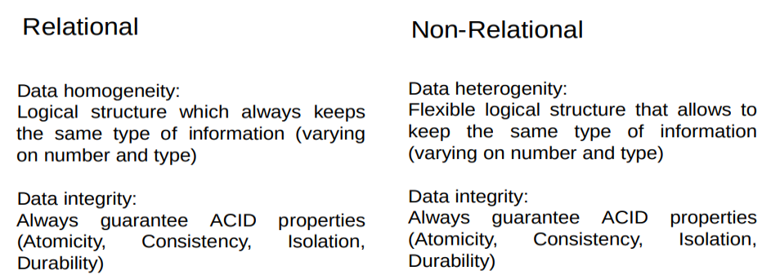

In order to guarantee a proper operation of all applications using data stored in a DB, the system must:

Guarantee the data integrity

Be efficient

Grant independency between program code and data format

**INTEGRITY**

Content consistency and coherence of information stored in the DB.

Avoid redundancy which are incorrect or duplicated values in the requested information.

DBS must guarantee the data integrity when content is modified (insert, update and changes propagation).

Incoherence in integrity == incorrect values (DNI negatiu)

Inconsistency in integrity == same query gives different results depending on its implementation.

Redundance in integrity == repeated information (leads to risks of inconsistencies, duplicate tasks or more disk usage)

Most common architecture are :

ANSI/SPARC which has three levels (for users)

* External level: is everything the users see in the website
* Conceptual level: here is where the data is
* Internal level: detailed description of all the elements stored in the database, part more related to the hardware.

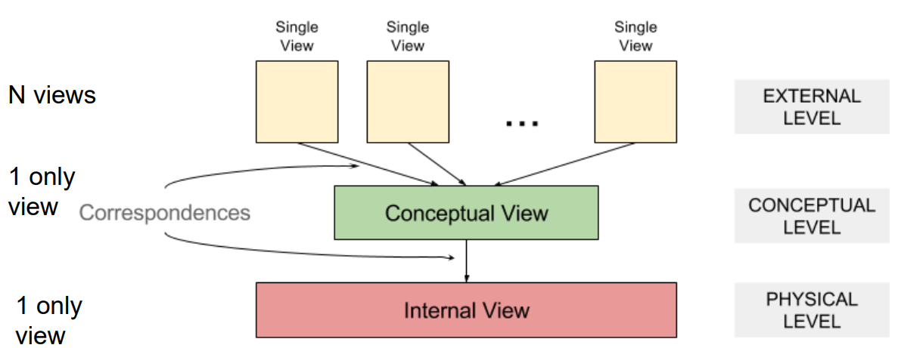

**EXTERNAL LEVEL**

Final user. Accessing via SQL or some application

Application. Developed with high-end programming languages (C++, PASCAL,…) which incorporate a Data Sub Language (DSL)

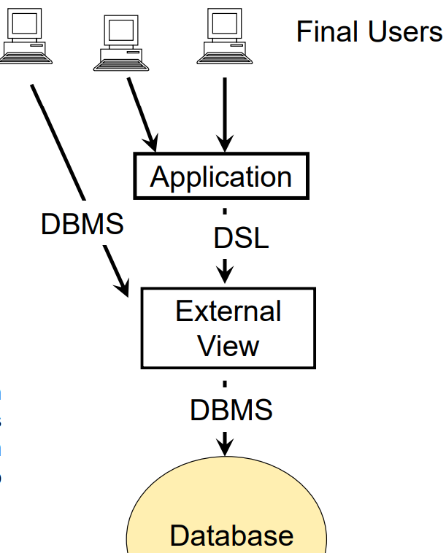

**CONCEPTUAL LEVEL**

Defined based on DDL conceptual (script SQL: create table, create domain, create foreign key, …)

Specify integrity and security controls

**INTERNAL LEVEL**

Content of the files which store the content of tables.

Files description according the operating system format.

Does not match with conceptual view (data distributed in different files)

Server- Client

Structuring the DB according the type of application (software) that are executed on the DB in 2 levels

